Net Zero Leaders
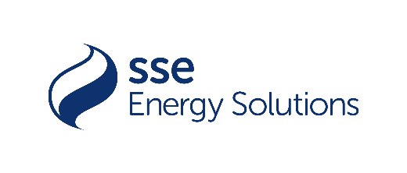

Partnered by
No longer a buzzword phrase, Net Zero is here to stay and the way forward for all businesses. How are you helping your customers to be a better business which helps us get a better planet? We are looking for those companies partnering with customers on their journey to Net Zero – how have you helped to reduce carbon, use less energy, save water, reduce waste and pollution?
Please take no more than 750 words to explore what you have done around Net Zero in the last 12 months. Judges will be looking for
- What does Net Zero mean to you and your customers?
- What Net Zero solutions have you implemented for you and your customers?
- How have you and your customers benefitted from these solutions?
- How are you ensuring that your Net Zero solutions are equitable for all your customers, large and small?
- How are you navigating the fast changing policy landscape around Net Zero?

Please note that numbers, stats and customer examples make a difference!
Please send your answer in a Word document to Bruna Pinhoni at Bruna.p@energylivenews.com.
All entries must adhere to the following guidelines:
- Entries need to be in by 5 p.m. September 23rd.
- There is a minimum score requirement to be shortlisted on all awards.
- The top ten scoring consultancies above the minimum score requirement will make up the shortlist for an award. The shortlists will be announced week commencing October 28th.
- Please note the word limits on all entries. Any entries over the limit will be truncated.
- You may use up to 3 pictures or web links in your entries.
- Judges’ decisions are final and binding; and no discussions or correspondence will be entered into relating to any of their decisions.
- ELN may contact industry players and bodies to ensure the validity of the TPI's claims.
- If you are shortlisted for one or a number of awards, you will receive two free tickets for the TELCA Awards Ceremony. Additional tickets are £400 ex VAT each.

