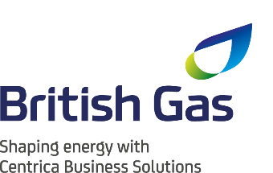
Net Zero Hero

Partnered by

Who is the person in your organisation helping customers to go Net Zero, explaining the complexities, simplifying the processes and making a difference.
Please take no more than 500 words to describe the person and what he/she is doing to make your customers more Net Zero. You should consider but not be limited to
- How is he/she helping customers?
- What impacts have you seen?
- What do your customers think of this person?
- Why do you think he/she makes such a difference?
- How is he/she navigating the Net Zero policy landscape and please give examples?

Please note that numbers, stats and customer examples make a difference!
Please send your answer in a Word document to Bruna Pinhoni at Bruna.p@energylivenews.com.
All entries must adhere to the following guidelines:
- Entries need to be in by 5 p.m. September 23rd.
- There is a minimum score requirement to be shortlisted on all awards.
- The top ten scoring consultancies above the minimum score requirement will make up the shortlist for an award. The shortlists will be announced week commencing October 28th.
- Please note the word limits on all entries. Any entries over the limit will be truncated.
- You may use up to 3 pictures or web links in your entries.
- Judges’ decisions are final and binding; and no discussions or correspondence will be entered into relating to any of their decisions.
- ELN may contact industry players and bodies to ensure the validity of the TPI's claims.
- If you are shortlisted for one or a number of awards, you will receive two free tickets for the TELCA Awards Ceremony. Additional tickets are £400 ex VAT each.

