Most Trusted Consultancy - SME Customers
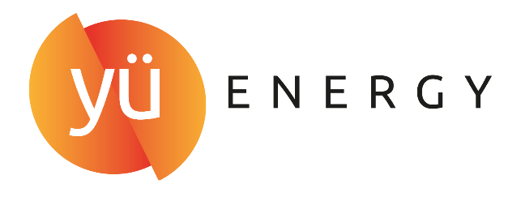
Partnered by

The Energy Broker/Consultancy sector is facing unprecedented challenges – high energy prices, mis-selling claims, reputational issues, supplier demands, customer expectations. This award is for the broker or consultant which can demonstrate its integrity when it comes to their customers, business dealings and reputation. Do you have what it takes to be the Most Trusted in the market?
Please take no more than 1000 words to explain how you show trust and integrity in your dealings with customers. Judges will be looking for
- Transparency.
- Fairness.
- Value for money.
- Fees and commission.
- How you charge and why?
- Customer examples where you have shown integrity.
- Go live rate.
- Retention rate.
- Conflict resolution process.
- How do you get the best deal for your customer?
- Your ethical motivation.
Please note that numbers, stats and customer examples make a difference!
Please send your answer in a Word document to Bruna Pinhoni at Bruna.p@energylivenews.com.
All entries must adhere to the following guidelines:
- Entries need to be in by 5 p.m. September 23rd.
- There is a minimum score requirement to be shortlisted on all awards.
- The top ten scoring consultancies above the minimum score requirement will make up the shortlist for an award. The shortlists will be announced week commencing October 28th.
- Please note the word limits on all entries. Any entries over the limit will be truncated.
- You may use up to 3 pictures or web links in your entries.
- Judges’ decisions are final and binding; and no discussions or correspondence will be entered into relating to any of their decisions.
- ELN may contact industry players and bodies to ensure the validity of the TPI's claims.
- If you are shortlisted for one or a number of awards, you will receive two free tickets for the TELCA Awards Ceremony. Additional tickets are £400 ex VAT each.

