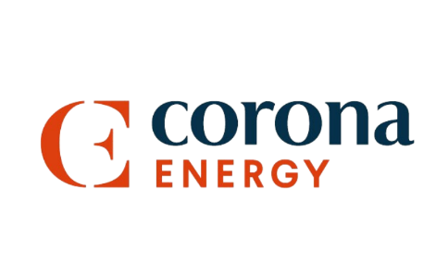
Industry Expert

Partnered by

Who is the person in your organisation who everyone (clients, team members, management) turns to for answers and advice in the Energy and Net Zero Space. The person who explains the complexities, simplifies the processes and makes a massive difference.
Please take no more than 500 words to describe the person and what he/she is doing to be Industry Expert in the TPI space. You should consider but not be limited to
- How is he/she helping customers?
- How is he/she helping your team and company?
- What impacts have you seen?
- What do your customers think of this person?
- Why do you think he/she makes such a difference?

Please note that numbers, stats and customer examples make a difference!
Please send your answer in a Word document to Bruna Pinhoni at Bruna.p@energylivenews.com.
All entries must adhere to the following guidelines:
- Entries need to be in by 5 p.m. September 23rd.
- There is a minimum score requirement to be shortlisted on all awards.
- The top ten scoring consultancies above the minimum score requirement will make up the shortlist for an award. The shortlists will be announced week commencing October 28th.
- Please note the word limits on all entries. Any entries over the limit will be truncated.
- You may use up to 3 pictures or web links in your entries.
- Judges’ decisions are final and binding; and no discussions or correspondence will be entered into relating to any of their decisions.
- ELN may contact industry players and bodies to ensure the validity of the TPI's claims.
- If you are shortlisted for one or a number of awards, you will receive two free tickets for the TELCA Awards Ceremony. Additional tickets are £400 ex VAT each.

