**Best Low Carbon Solution**

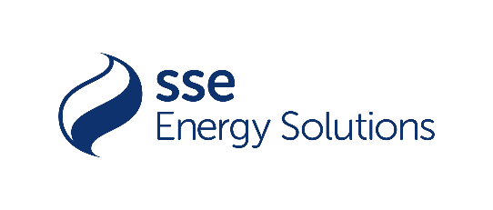

Partnered by

**Customers are under pressure to go Net Zero, to be Low Carbon. How are you helping them to be low carbon, to progress on their Net Zero journey? What customer solution (technology, innovation, product, service offering) have you provided in the last 12 months which has made a positive difference to a customer or set of customers?**

Please take no more than 750 words to explore how you helped a customer or group of customers with low carbon solutions in the last 12 months. It could be the use of PPAs, embedded renewable generation, renewable technologies, etc. Judges will be looking for:

* What you proposed and why?
* What impacts have been realised?
* How has the use of low carbon solutions helped your customers?
* Financial implications of the solution e.g. cost/savings/ROI?

Please note that numbers, stats and customer examples make a difference!

Please send your answer in a Word document to Bruna Pinhoni at [Bruna.p@energylivenews.com](mailto:Bruna.p@energylivenews.com).

All entries must adhere to the following guidelines:

1. Entries need to be in by 5 p.m. September 23rd.
2. There is a minimum score requirement to be shortlisted on all awards.
3. The top ten scoring consultancies above the minimum score requirement will make up the shortlist for an award. The shortlists will be announced week commencing October 28th.
4. Please note the word limits on all entries. Any entries over the limit will be truncated.
5. You may use up to 3 pictures or web links in your entries.
6. Judges’ decisions are final and binding; and no discussions or correspondence will be entered into relating to any of their decisions.
7. ELN may contact industry players and bodies to ensure the validity of the TPI's claims.
8. If you are shortlisted for one or a number of awards, you will receive two free tickets for the TELCA Awards Ceremony. Additional tickets are £400 ex VAT each.